**Combination & Permutation Class User Manual**

A Java-based collection of functions to solve for combinations and permutations

Cachary Tolentino

CSCI-3327

**Table of Contents**

**Software Description3**

Detailed Description3.1

System Requirements3.2

**Installation Guide4**

**Class Overview7**

**Software Description**

A Java-based collection of functions to solve for combinations and permutations

**Detailed Description**

The Combination and Permutation Class is a class collection of functions used for calculating combinations and permutations. It includes two separate functions for their respective functions.

**System Requirements**

* A working device, primarily a desktop or laptop
* An IDE (ex: VSCode, Eclipse, etc…)
* Java JDK (Ver. 17 & up) & JRE (SE 17 & up)

**Installation Guide**

To begin using the Combination&Permutation Software, first download “Solver.java”, and “TestSolver.java” (optional).

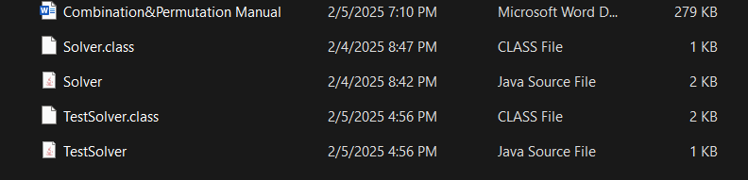

Once downloaded, you can either move the files to your project folder or directly open it in your desired IDE (we will be using VSCode in this tutorial). Open your IDE and open the folder containing the files.

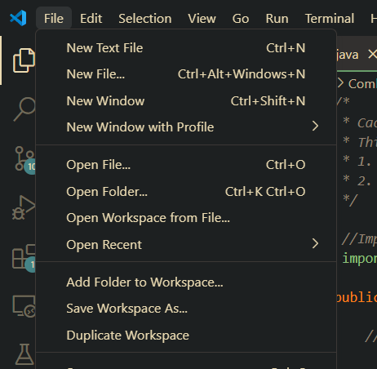

Once opened, it should look similar to the following image.

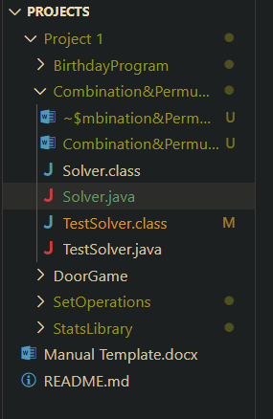

From here you can simply start using the classes as you would for any Java classes. But if you wanted to quickly test or see the results using the code then open the “TestSolver.java” file and run it. The output should look similar to the following image.

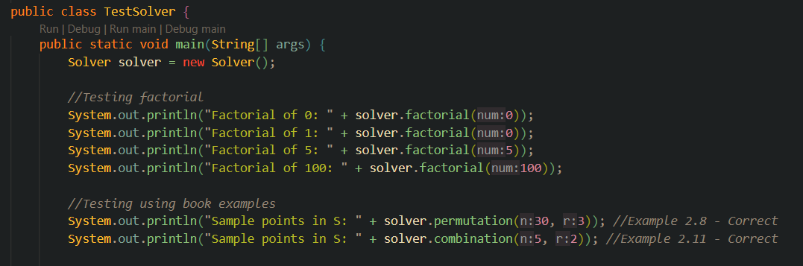

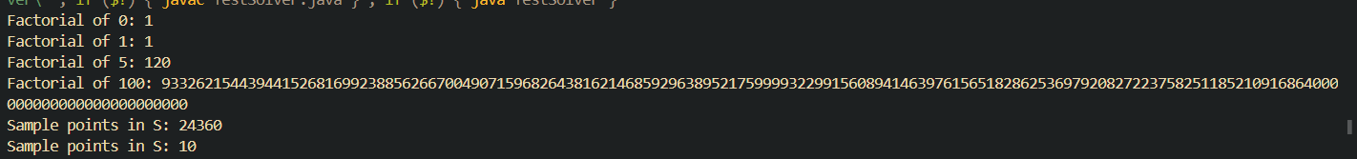

**Class Overview**

**Solver Class**

The Solver Class consists of multiple functions and a constructor. The class uses the BigInteger java package for calculating factorial. But the class does not require any global variables.

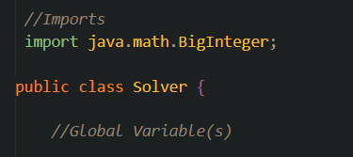

**Class Constructor**

**Default Constructor**

The default constructor takes no parameters. It also does not initialize any variables as the class does not have any global variables.

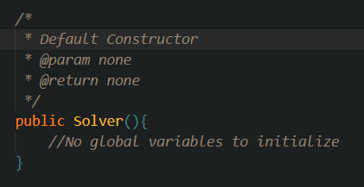

**Class Functions**

**factorial Function**

The factorial function calculates the factorial value of a given integer value. It takes in an int value as the number to find the factorial value. It returns a BigInteger value of the factorial. This is primarily used as a helper function for combination and permutation functions.

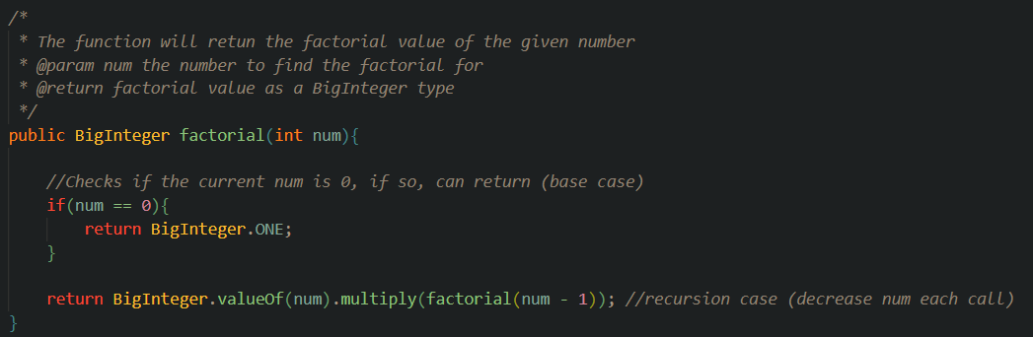

**combination Function**

The combination function calculates the combinatorial value of a given pair of integer values using the formula:

$$C_{r}^{n}=\frac{n!}{r!\left(n-r\right)!}$$

It uses the factorial function to find the factorial value. It will then return the value as a BigInteger value.

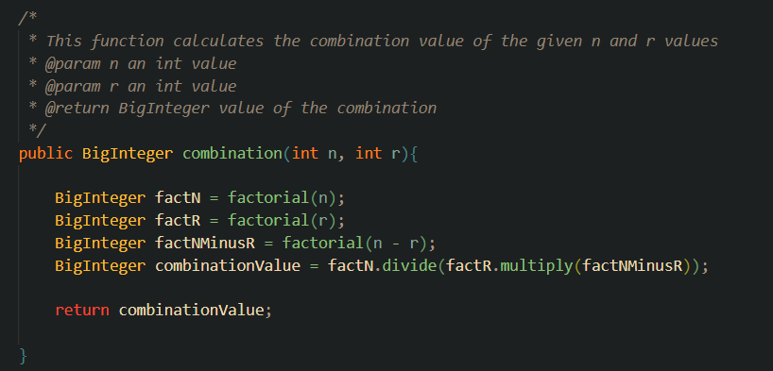

**permutation Function**

The permutation function calculates the permutation value of a given pair of integer values using the formula:

$$P_{r}^{n}=\frac{n!}{\left(n-r\right)!}$$

It uses the factorial function to find the factorial value. It will then return the value as a BigInteger value.

